**Installing Jenkins as Standalone Jar on Ubuntu**

**Purpose:**

This lab will install the jenkins as an application.

**Steps:**

1. SSH to the Server created on cloud from any terminal from Google console.
2. Type following commands

**sudo su  
apt-get update && apt-get upgrade -y**

1. Install Java by running the following command in sequence: -

**apt-get install openjdk-8-jre-headless -y  
apt-get install openjdk-8-jdk -y**

**java -version**

Note:You may get message that java is already installed,you can ignore the message as it is already installed in our AWS Golden AMI used for labs.

1. Download Jenkins by running the following commands in sequence: -

**wget** [**https://updates.jenkins-ci.org/download/war/2.184/jenkins.war**](https://updates.jenkins-ci.org/download/war/2.184/jenkins.war)

**ls**

1. It will show that jenkins.war is downloaded.
2. Now run the following command:

**java -jar jenkins.war**

1. It will generate some password as shown below:

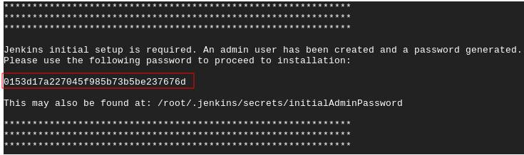

1. Copy the password.
2. Browse to http://<Public IP>:8080 and wait until the **Unlock Jenkins** page appears.
3. Enter the initialAdminPassword copied from step 7 above in the Unlock Jenkins and Click Continue.
4. Getting Started page should appear. Click on **Install Suggested Plugins.**
5. Once its default plugins are installed, **Create First Admin User page** should appear.
6. Enter **Username** as admin
7. Enter **Password** as admin
8. Enter **Confirm password** as admin
9. Enter **Full name** as your full name
10. Enter **E-mail address** as your email address.
11. Click **Save and Continue**
12. **Instance Configuration page** should appear**.**
13. Click **Save and Finish**
14. **Jenkins is ready! page** should appear**.**
15. Click **Start using Jenkins**
16. It should open the Jenkins Home page.

**Notes:**

* This page may indicate **Jenkins is almost ready!** instead and if so, click **Restart**.
* If the page does not automatically refresh after a minute, use your web browser to refresh the page manually.
* If it still do not load the Jenkins home page, then please rerun the command java -jar jenkins.war in your command prompt, Refresh the browser with URL: [http:///<public ip>:8080/](http:///localhost:8080/) and Login with the credentials of the admin user , you created in step 11-17.